|  |
| --- |
| Self encapsulate field |

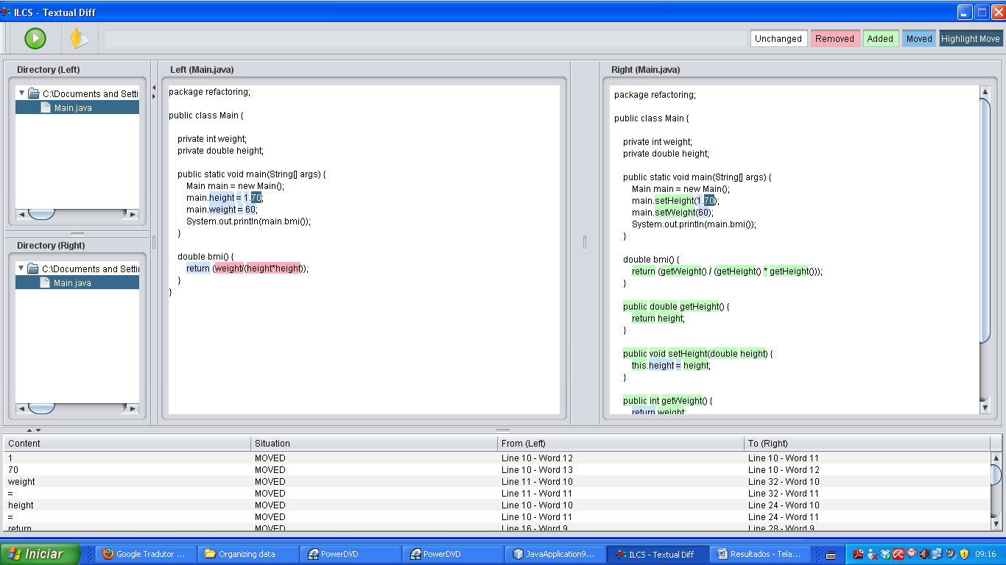

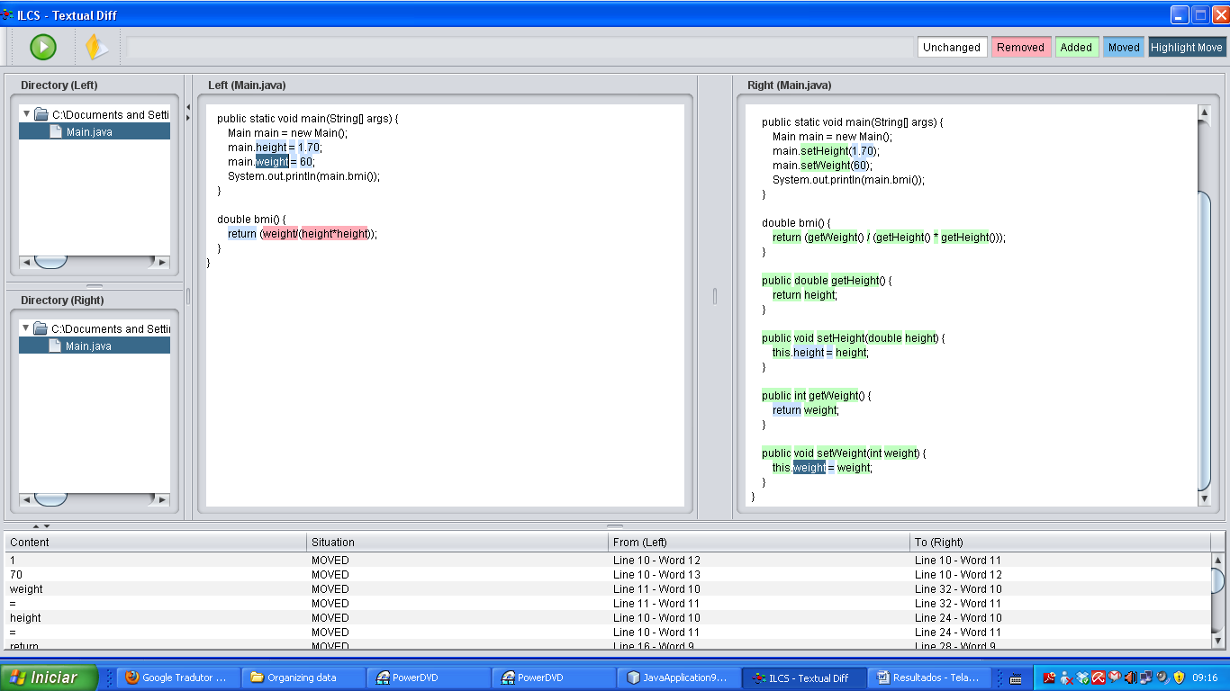

|  |
| --- |
| Replace data value with object |

|  |
| --- |
| Change value to reference |

|  |
| --- |
| Change reference to value |

|  |
| --- |
| Replace array with object |

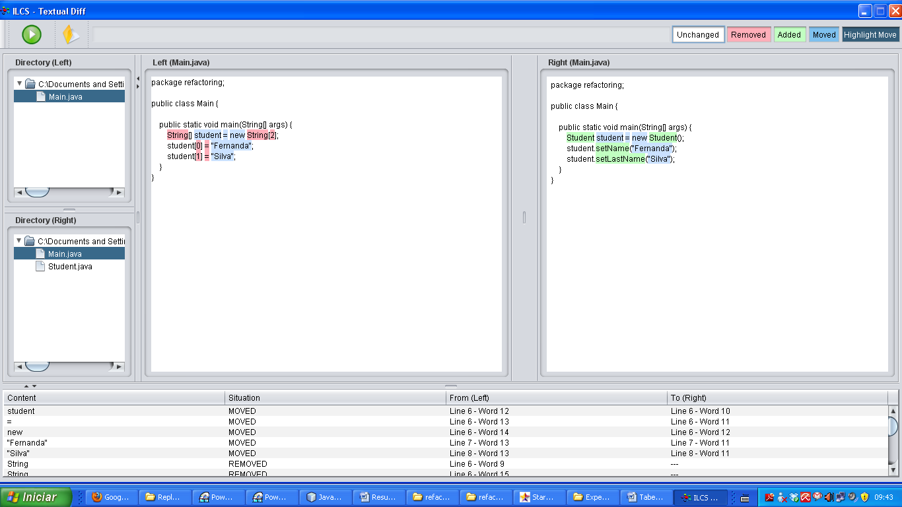

Percentual baixo de semelhança

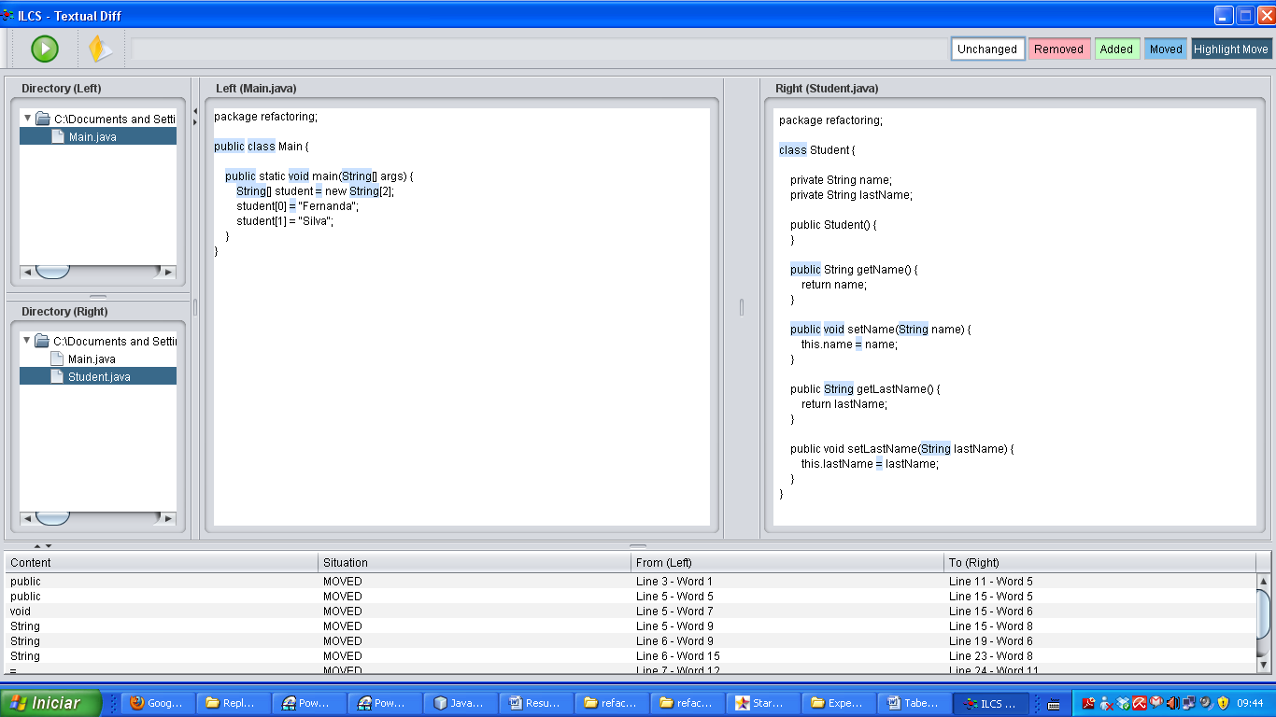

|  |
| --- |
| Duplicate observed data |

|  |
| --- |
| Change unidirectional association to bidirectional |

|  |
| --- |
| Change bidirectional association to unidirectional |

|  |
| --- |
| Replace magic number with symbolic constant |

|  |
| --- |
| Encapsulate field |

|  |
| --- |
| Encapsulate collection |

|  |
| --- |
| Replace record with data class |

|  |
| --- |
| Replace type code with class |

|  |
| --- |
| Replace type code with subclass |

|  |
| --- |
| Replace type code with state/strategy |

|  |
| --- |
| Replace subclass with fields |